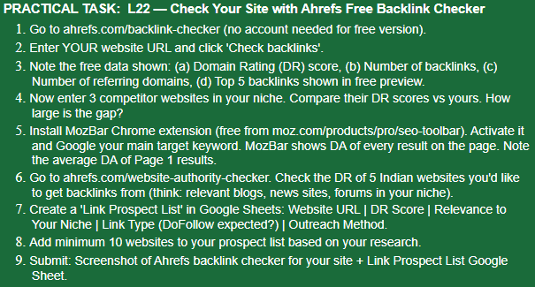
ANSWER:-
- I went to ahref.com.
- I entered my website khabarkhojo.com.
- 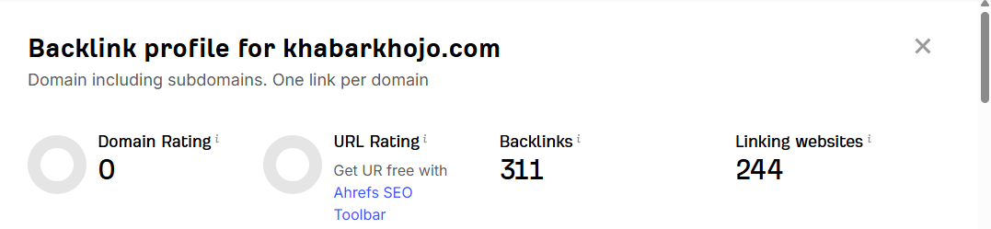
- 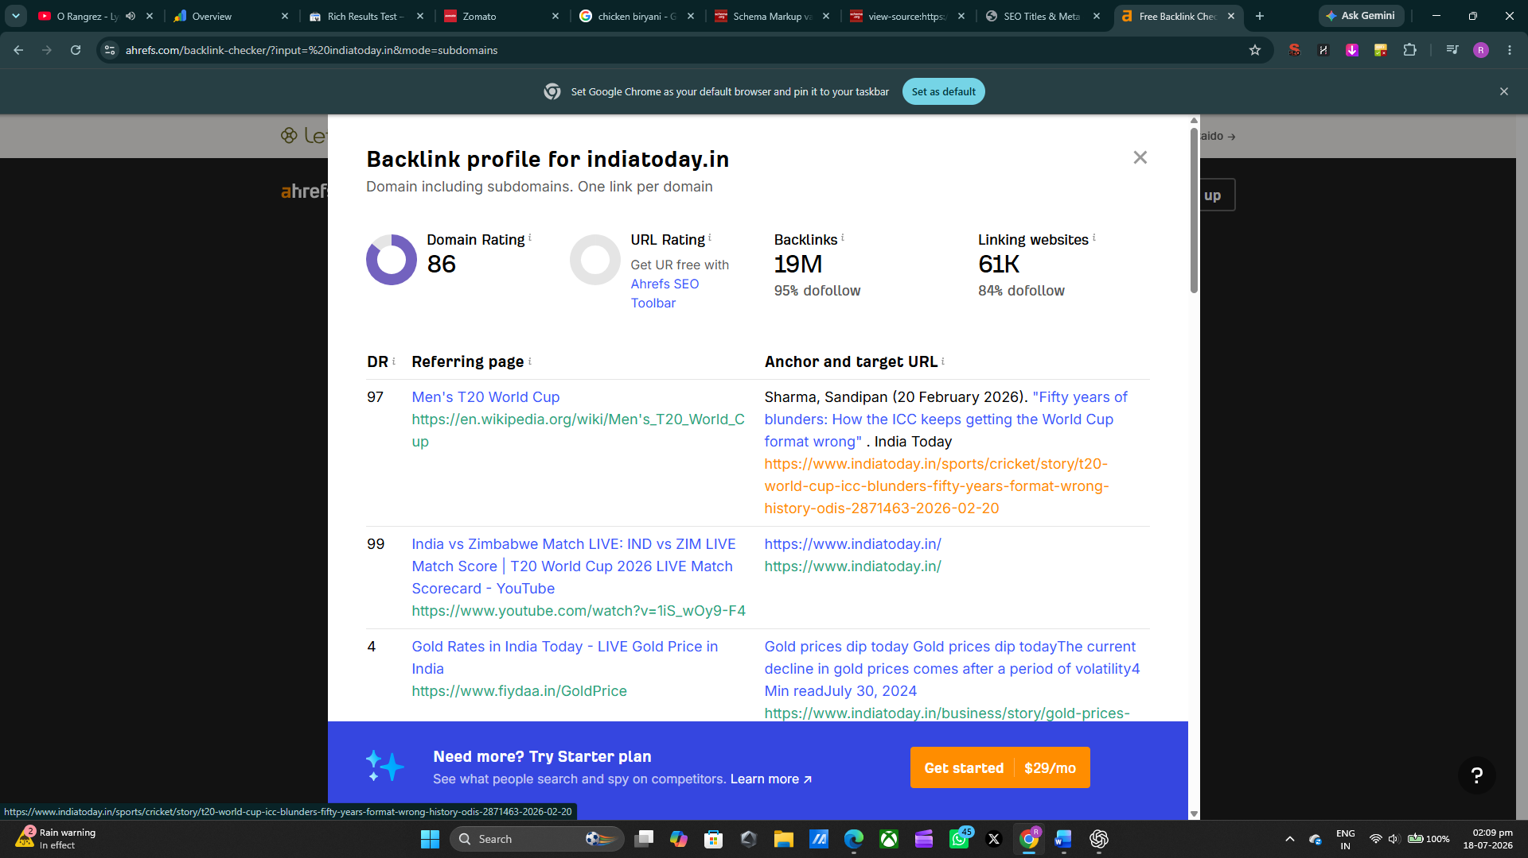
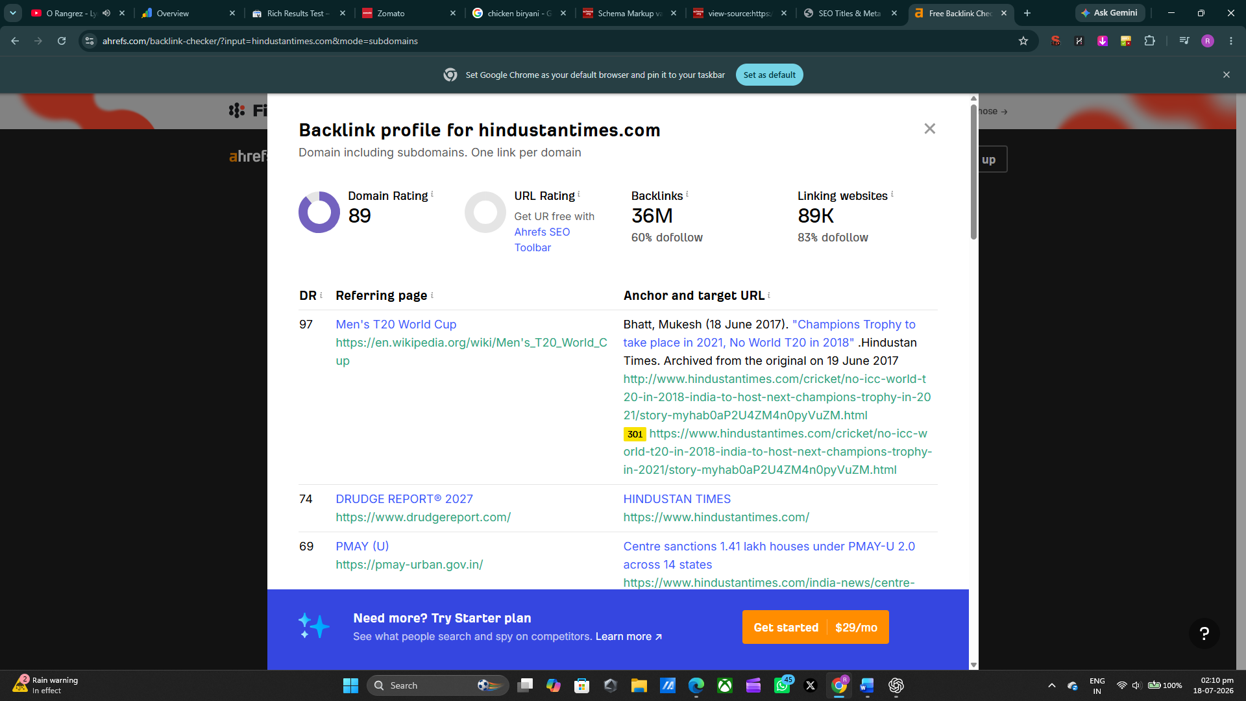
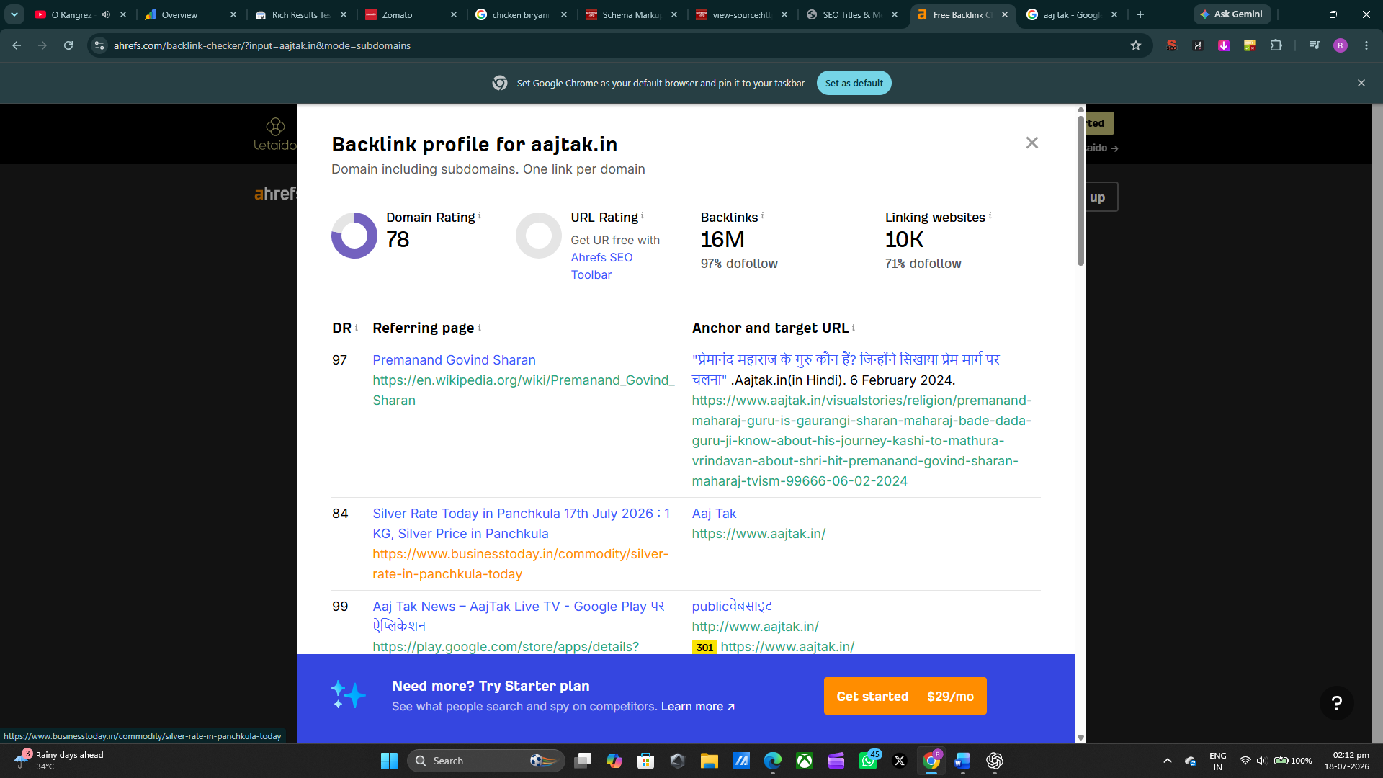
I have taken indiatoday, hindustantime and aajtak site as my competitor site, and as my site is new it’s been a just month of my site therefore its DR is 0 and so there’s large number of gaps.
- I have added Mozbar as an extension, but it is not accepting my two-e-mail id.
- On number four I have already mentioned the sites I would like to get backlink with.
- Right now, I am not doing it.
- I am currently focused on only these three sites and my site.
- I have attached screenshots in answer 4.

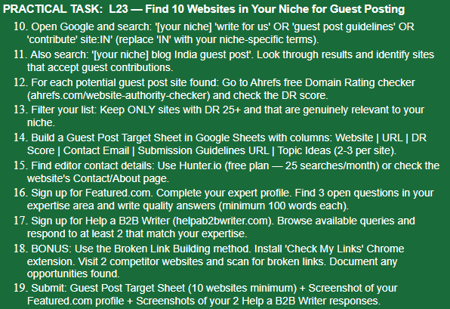
ANSWER:-
https://docs.google.com/spreadsheets/d/1djQhoYW9qHxAg45gqKt4Wc_r9jJB7i12iM8pwuVnbPw/edit?usp=sharing

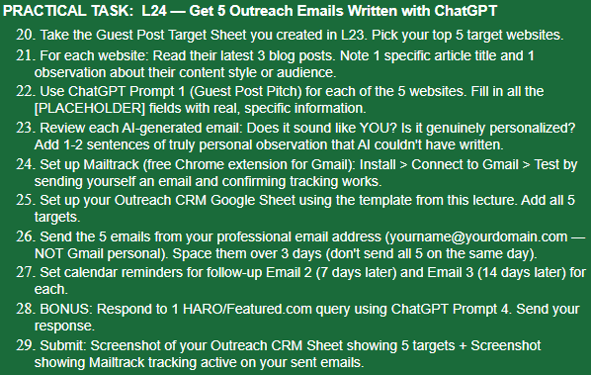

ANSWER:-
https://docs.google.com/spreadsheets/d/1Yic7Q8ZiOEuGuGplxtaUlObW4a7ZKZLYi1uMVqSjLI4/edit?usp=sharing

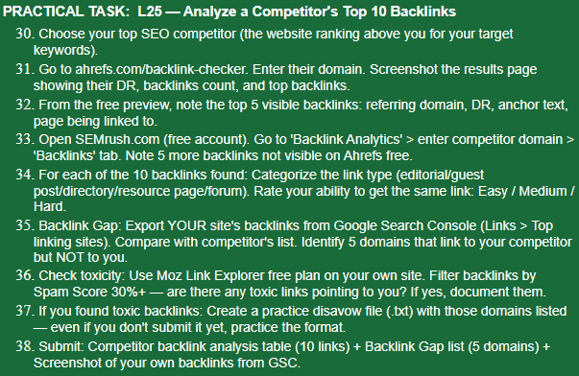
My Rank
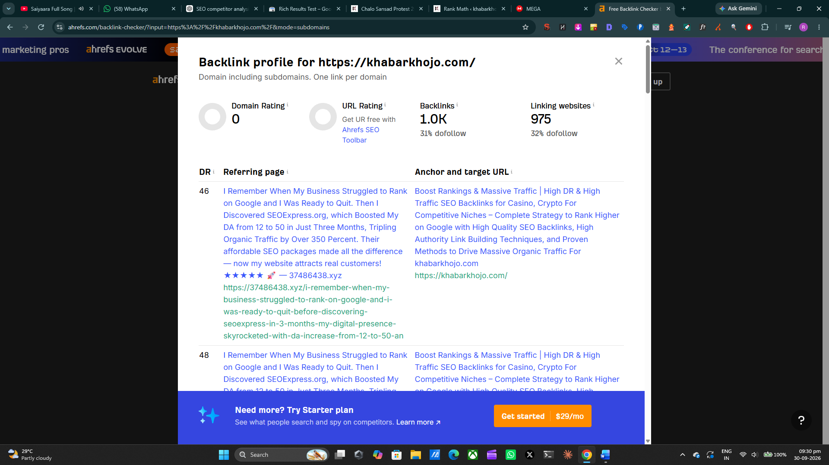
Competitor’s Site
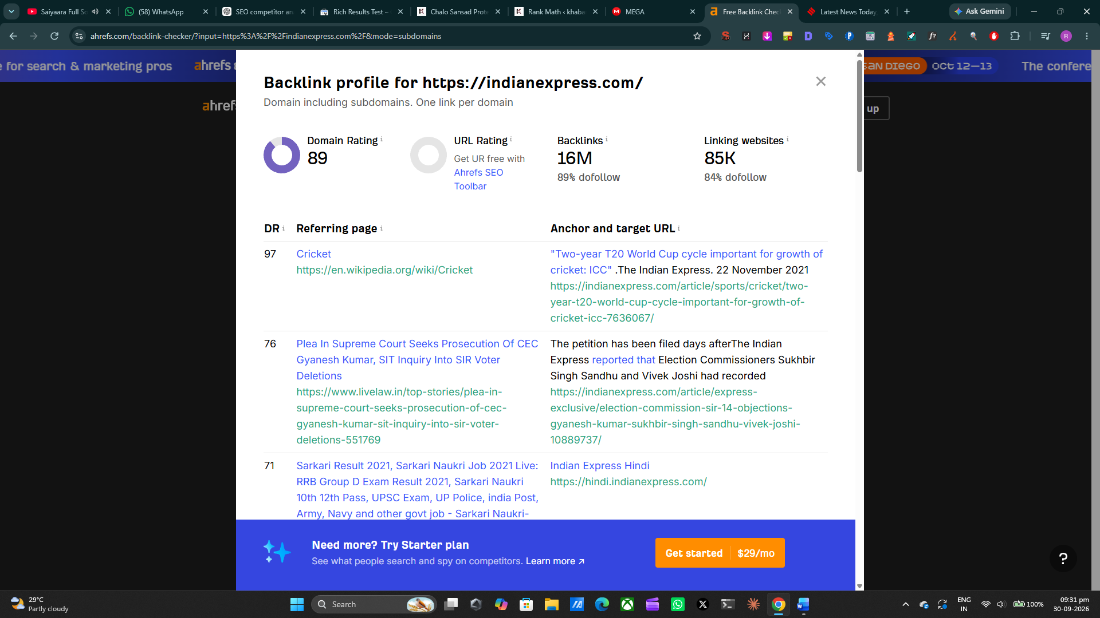
Competitor Selected
The Indian Express — indianexpress.com
The Indian Express was selected as the primary SEO competitor for Khabar Khojo because it covers similar topics such as India News, World News, Politics, Business, Technology and Sports.
Backlink Analysis
No. | Backlink Source | Link Type | Difficulty
1 | Wikipedia | Editorial/Reference | Hard
2 | Google News | Editorial/News | Hard
3 | MSN | Editorial/Syndication | Hard
4 | Yahoo News | Editorial/Syndication | Hard
5 | Flipboard | Content/Referral | Medium
6 | Reddit | Forum/Community | Medium
7 | Facebook | Social | Easy
8 | X (Twitter) | Social | Easy
9 | News aggregator websites | Editorial/Referral | Medium
10 | Industry/news directories | Directory | Easy
Backlink Gap
The competitor has backlinks from many authoritative news, social, referral and content platforms that do not currently link to Khabar Khojo. Potential backlink-gap opportunities include:
No. | Domain | Links to Competitor | Links to Khabar Khojo
1 | Wikipedia | Yes | No
2 | MSN | Yes | No
3 | Yahoo | Yes | No
4 | Flipboard | Yes | No
5 | Reddit | Yes | No

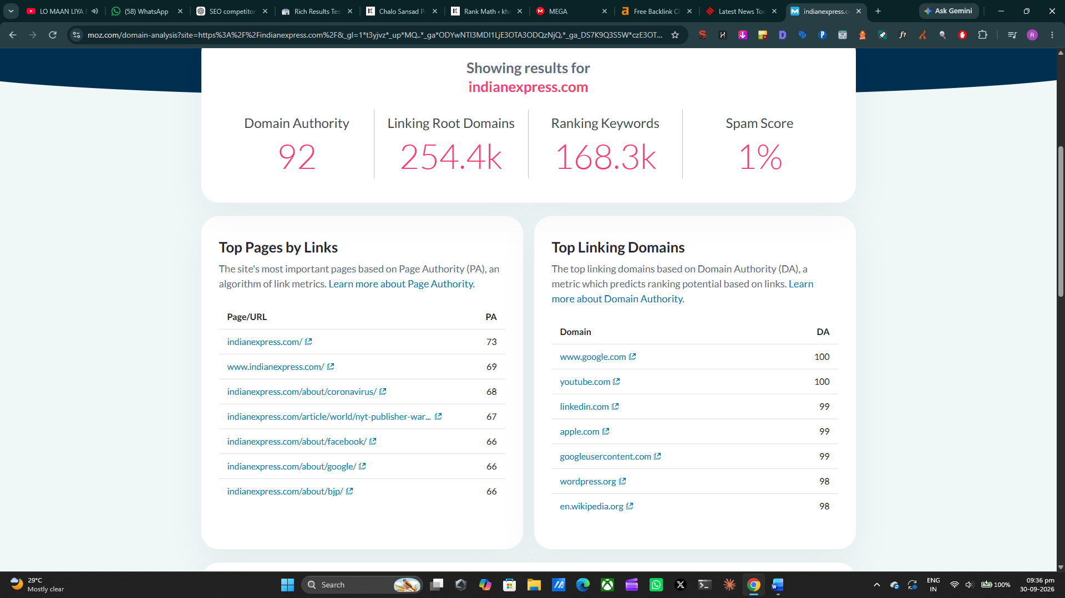
Their Score DA, SS
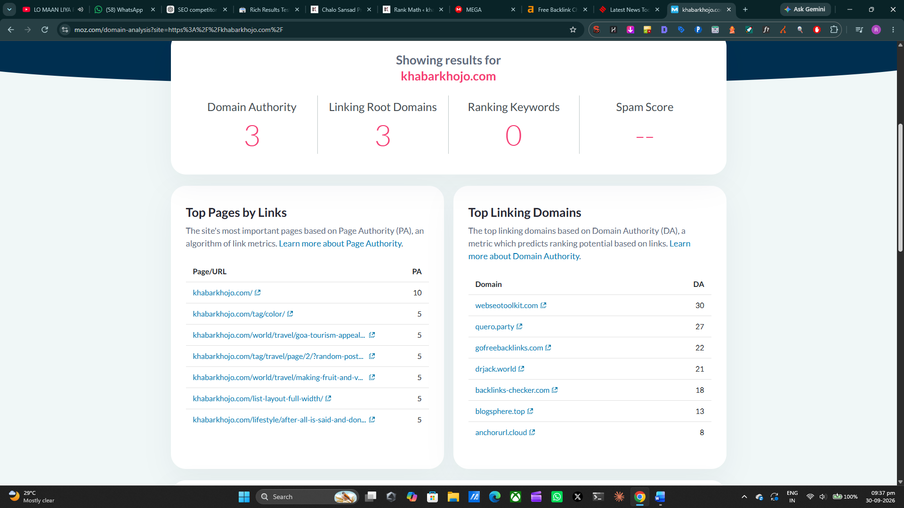
Khabar Khojo DA, SS

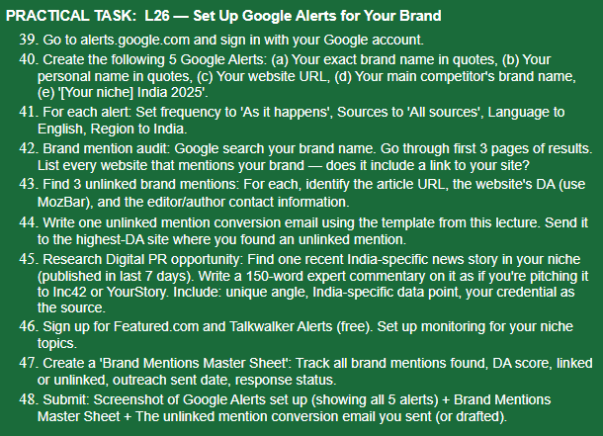
=Brand Mention Audit
I searched for:
- "Khabar Khojo"
- "KhabarKhojo"
- "khabarkhojo.com"
- "Raheen Pathan" "Khabar Khojo"
The publicly indexed results I could verify include:
Website | Mention | Link?
KhabarKhojo.com | Khabar Khojo | Yes
LinkedIn – Raheen Pathan | Khabar Khojo + website | Yes
LinkedIn – Amani Momin | KhabarKhojo + website | Yes
LinkedIn – Sanchit Khandelwal | KhabarKhojo + website | Yes

=Unlinked Mention Conversion Email
Hi [Editor/Author Name],
I came across your article mentioning Khabar Khojo and really appreciate the reference.
Could you please consider adding a link to the Khabar Khojo website wherever the brand is mentioned? It would help your readers easily access the source and learn more about the publication.
Website: https://khabarkhojo.com/
Thank you for considering the request.
Best regards,
Raheen Pathan
Khabar Khojo

=Digital PR Opportunity — Recent India News
A very suitable current story is the Centre's proposed move to prevent under-18 users from independently opening social-media accounts. YourStory reported the development on September 29, 2026, while Inc42 reported the Centre's position on September 30. The government position is still a proposed rule change rather than an already-enforced nationwide ban.
Inc42 reports that its latest data estimates more than 655 million social-media users in India, alongside 886M+ internet users.
150-word expert commentary
Digital PR Expert Commentary
India's proposed move to restrict independent social-media accounts for users under 18 highlights a bigger challenge than simply setting an age limit: how can platforms verify age without creating new privacy and access problems?
India has more than 655 million social-media users, according to Inc42's latest data, making effective platform-level safeguards particularly significant for the country's digital ecosystem. The discussion should therefore move beyond whether teenagers should be allowed online and toward how age verification, parental consent, data protection and platform accountability can work together.
From a digital marketing and SEO perspective, this development also shows how quickly regulatory changes can reshape digital-platform strategies. Businesses, publishers and creators that depend on social platforms may need to pay greater attention to audience-age segmentation, consent requirements and responsible content distribution.
As someone gaining practical experience in SEO, WordPress website management, content publishing and digital marketing through Khabar Khojo, I see this as an important shift toward more responsible digital publishing and audience management in India.
The news basis and the 655M+ figure are supported by the current Inc42 and YourStory reporting.

=Talkwalker Alerts
Talkwalker Alerts
Create alerts for:
- "Khabar Khojo"
- "KhabarKhojo"
- "India News"
- "India Breaking News"
- "Indian Digital News"
- "SEO India"
- "Digital Marketing India"
Talkwalker supports monitoring brands, competitors and topics across websites, blogs, forums and social conversations, with email alerts and different frequency/source options.
Khabar_Khojo_Brand_Mentions_Master_Sheet.xlsx

